Comprehensive Report on Current State of Upper Arm Prosthetics Interfacing with the Brain
Name: James Dapogny
Project Background: This report was generated through Cursor. All sources were found by me and given to cursor to read. Additionally, Cursor aided in teaching and helped me understand the material that I way I can explain the main points and most important aspects of all the sources.
Brain-Computer Interfaces and Robotic Prosthetics: Current Evidence and Clinical Direction
Introduction
Brain-computer interfaces (BCIs) for prosthetic control have progressed from basic proof-of-concept systems to clinically meaningful demonstrations of robotic limb control, sensory feedback, and task-level function (Flesher et al., 2021; Handelman et al., 2022; Schwartz et al., 2006). At the same time, the field remains translationally constrained by long-term reliability, maintenance burden, endpoint inconsistency across studies, and reimbursement uncertainty (Bowsher et al., 2016; FDA, 2021; Loeb & Richmond, 2021).
This report synthesizes the source set you provided, with emphasis on five guiding questions and their implications for near-term research and deployment decisions.

Are BCIs the future of prosthetics?
BCIs are likely to be a major part of the future of prosthetics, but not the sole pathway for all users. The strongest evidence supports BCI value in high-need populations (e.g., severe paralysis, high-complexity control demands), where direct neural decoding can provide function not easily achieved through conventional control channels (Lee et al., 2019; Schwartz et al., 2006). Human studies show that cortical control can support multi-degree-of-freedom robotic tasks and ADL-relevant activities, including bimanual workflows under shared-control paradigms (Handelman et al., 2022).
However, “future” should not be interpreted as “BCI-only.” The literature on usability, affordability, and practical adoption shows that many users benefit from less invasive systems when those systems offer adequate function with lower burden (Liu et al., 2023; Ku et al., 2019). In parallel, peripheral bidirectional systems and advanced myoelectric approaches continue to improve and may be more scalable in broader clinical environments (Cady et al., 2025).
Therefore, the most evidence-consistent conclusion is that future prosthetic care will be stratified and multimodal. BCIs will likely be foundational for selected populations, while peripheral, myoelectric, and hybrid systems remain central to broad access and long-term serviceability (Loeb & Richmond, 2021).
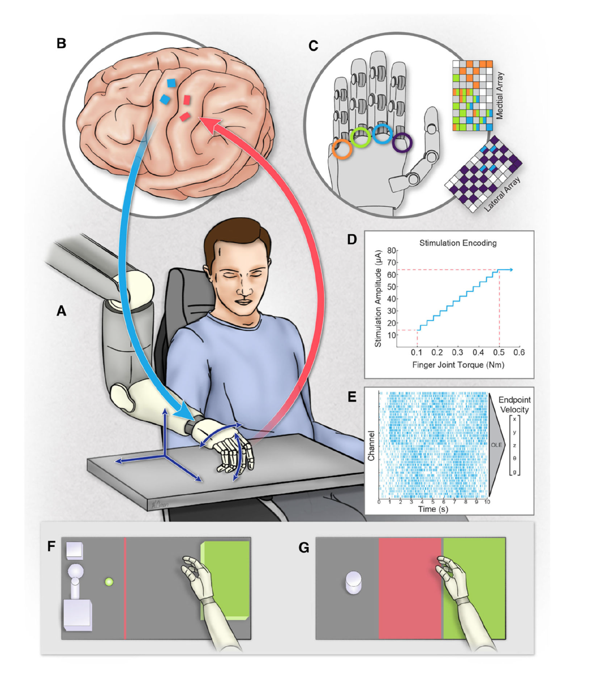
Figure 1. Bidirectional BCI architecture linking motor cortical decoding to robotic actuation and somatosensory intracortical stimulation. Adapted from Flesher et al. (2021).

What advantages/disadvantages exist with BCIs for prosthetics?
BCI advantages are strongest in control richness and closed-loop integration. Direct neural signals can support high-dimensional control mapping and reduce dependence on residual peripheral anatomy (Schwartz et al., 2006). Sensory-enabled BCIs add a second major advantage: improved object interaction efficiency and confidence when tactile-like feedback is available (Flesher et al., 2021). This is critical because upper-limb manipulation is not purely positional; grasp transitions, force modulation, and object state sensing are central to performance.
A further advantage is architectural flexibility. BCI input can be combined with shared autonomy, allowing users to provide high-level or constrained low-level intent while robotic controllers handle subtasks. This has clear implications for complex bimanual activities where direct full-DOF manual control is impractical (Handelman et al., 2022).
The disadvantages are equally important. Implanted systems introduce surgical and hardware lifecycle risks, and chronic interface behavior remains a major translational concern even with encouraging long-term findings in stimulation stability studies (Callier et al., 2015; Chen et al., 2014). Operationally, these systems often require recurring calibration, specialized teams, and robust support infrastructure, which limits immediate scalability (Bowsher et al., 2016; FDA, 2021). Economic and reimbursement pathways remain another barrier, especially when device complexity exceeds current payer evidence expectations (Loeb & Richmond, 2021).
In short, BCIs currently offer some of the highest functional potential but carry some of the highest system burden. Their real-world success depends on whether reliability, workflow, and reimbursement can keep pace with technical capability.
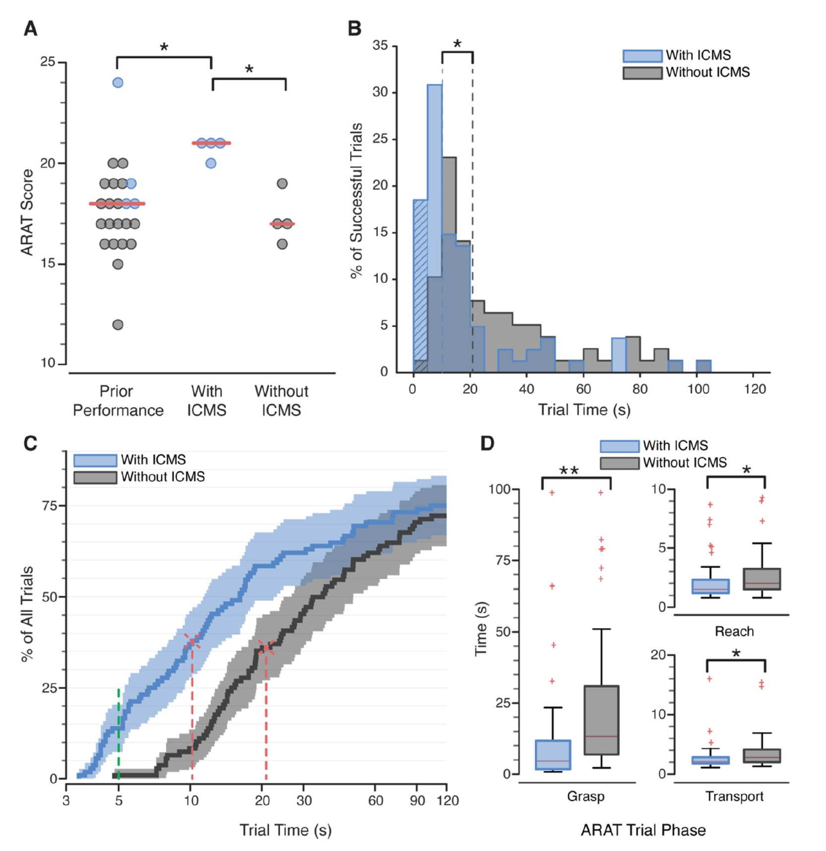
Figure 2. Functional task performance improved with ICMS sensory feedback compared with vision-only control. Adapted from Flesher et al. (2021).

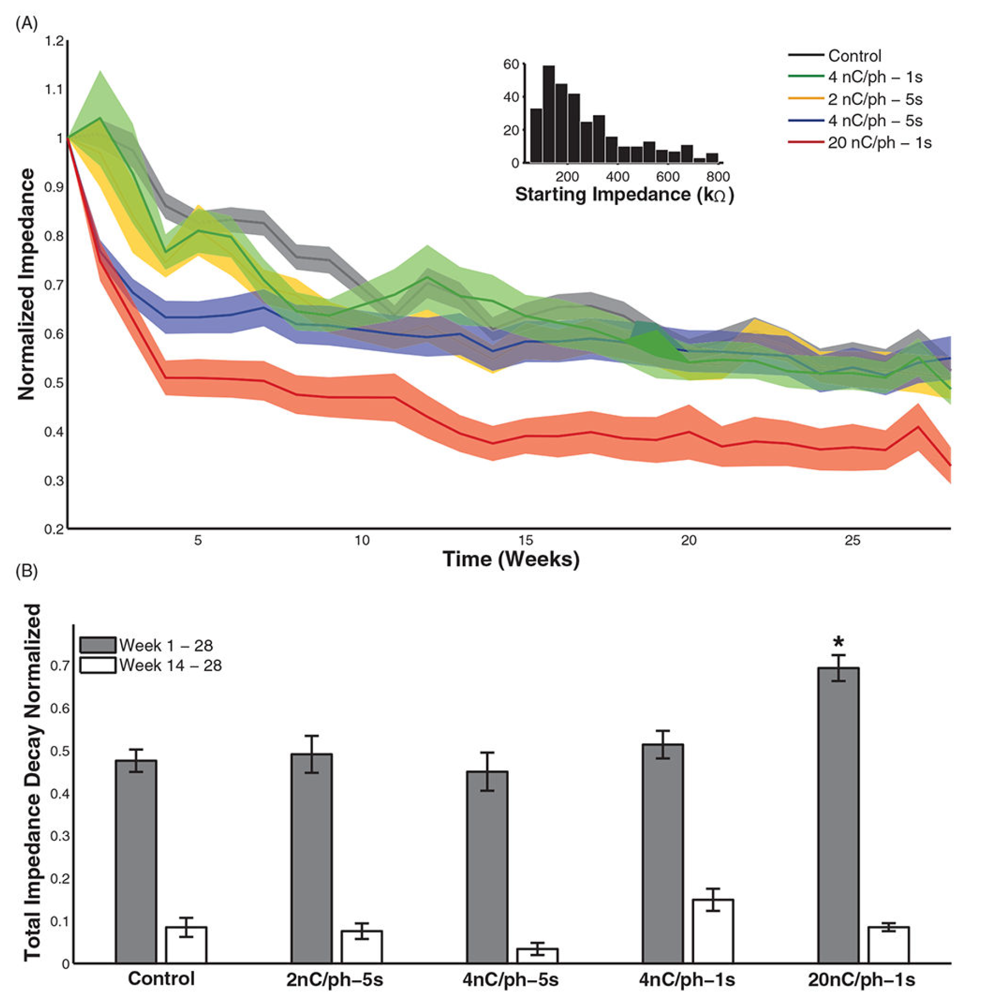
Figure 3. Longitudinal changes in electrode impedance during chronic intracortical microstimulation, illustrating stability trends and parameter-dependent interface evolution over time. Note. Adapted from “The effect of chronic intracortical microstimulation on the electrode–tissue interface,” by K. H. Chen et al., 2014, Journal of Neural Engineering, 11(2), 026004 (https://doi.org/10.1088/1741-2560/11/2/026004). Copyright 2014 by IOP Publishing Ltd.

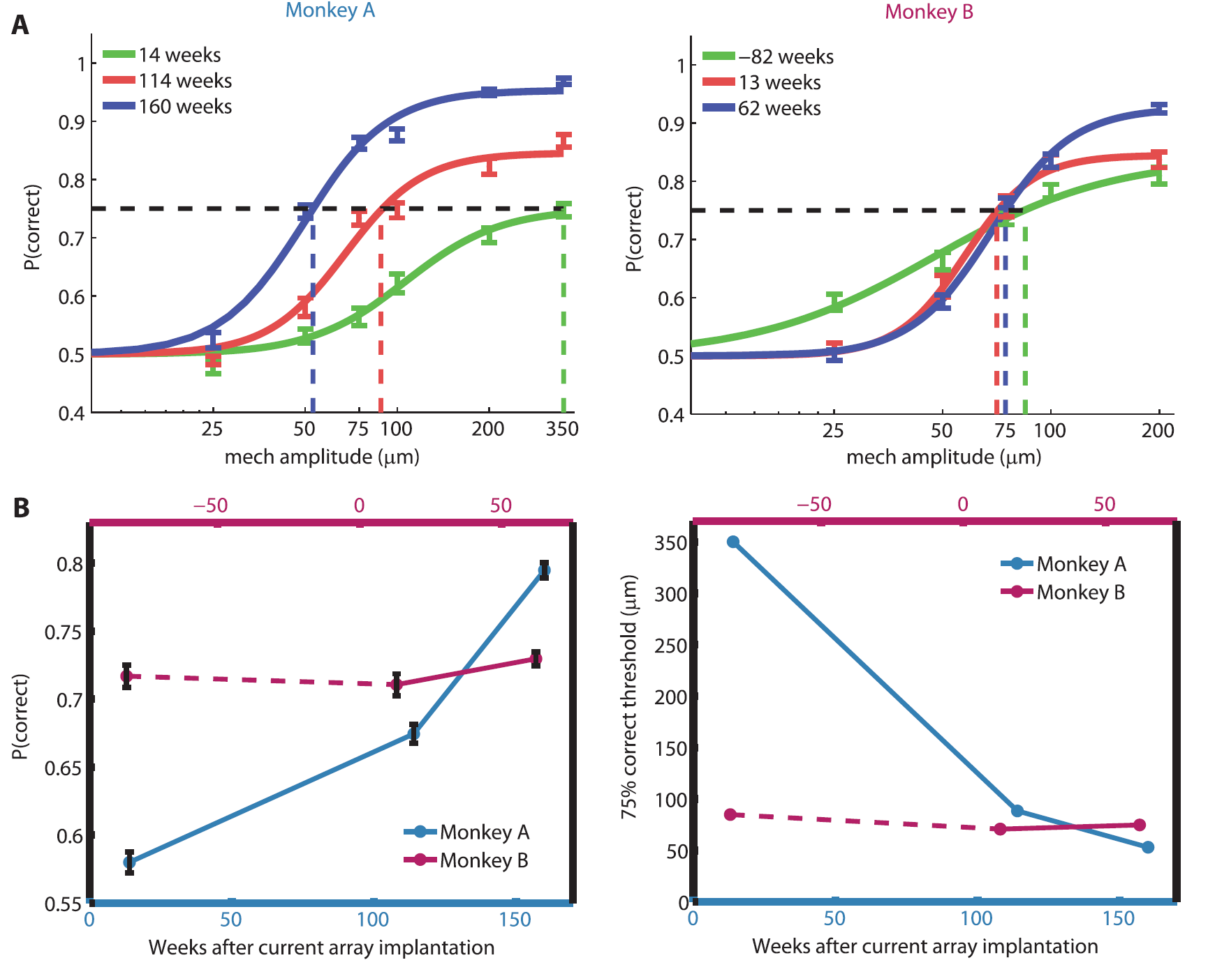
Figure 4. Long-term stability of behavioral sensitivity to intracortical microstimulation of somatosensory cortex assessed across repeated survey periods. Note. Adapted from “Long-term stability of sensitivity to intracortical microstimulation of somatosensory cortex,” by T. Callier et al., 2015, Journal of Neural Engineering, 12(5), 056010 (https://doi.org/10.1088/1741-2560/12/5/056010). Copyright 2015 by IOP Publishing Ltd.

How do prosthetics for patients born without limbs compare to those who lost limbs later in life?
The evidence supports a meaningful distinction between congenital and acquired limb-loss populations. They should not be treated as interchangeable cohorts for prosthetic training or outcome interpretation. Developmental studies indicate that early-life limb experience changes later artificial-arm control trajectories (Maimon-Mor et al., 2021). Specifically, congenital and acquired groups can differ in error structure, adaptation dynamics, and visuomotor correction profiles during artificial-arm tasks.
Pediatric functional studies similarly show that both groups can improve with training, but baseline characteristics and progression patterns differ (Korkmaz et al., 2012). Congenital cohorts may demonstrate strong compensatory behavior without a prosthesis in some tasks, while prosthetic benefit depends heavily on fitting timing, daily usage, and task relevance (AAPM&R, n.d.; Korkmaz et al., 2012).
From a rehabilitation perspective, this means subgroup-specific pathway design is essential. Assessment, training intensity, sensory strategy, and expected milestones should be tailored by developmental history rather than assumed to be uniform. This conclusion is also consistent with broader clinical guidance emphasizing individualized function-first prosthetic decisions in congenital limb differences (AAPM&R, n.d.).

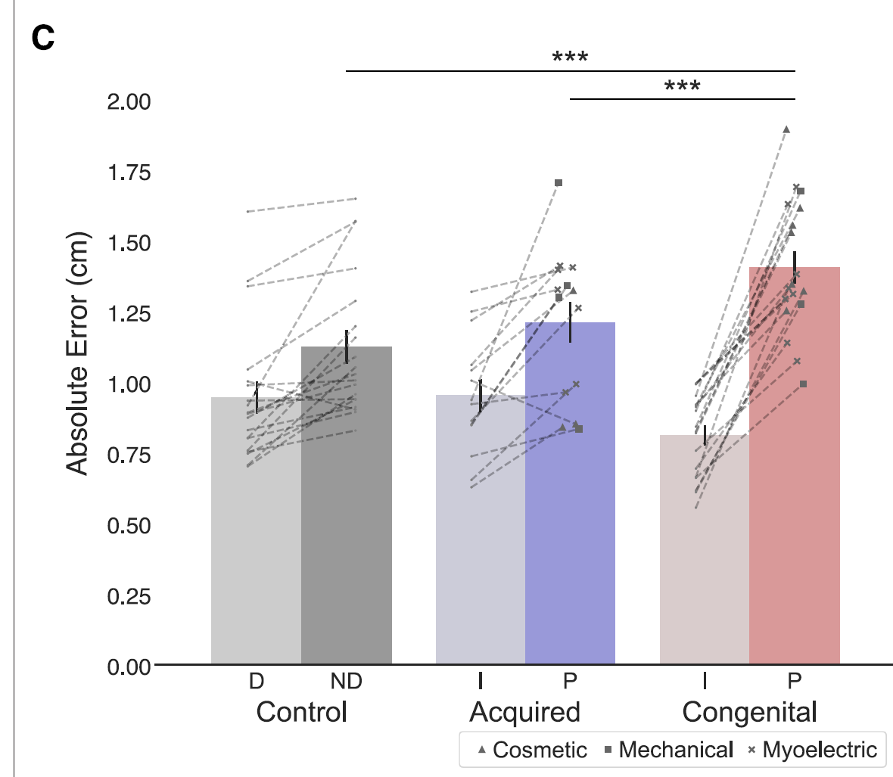
Figure 5. Artificial-arm reaching endpoint errors differ between adults with congenital limb difference and adults with acquired amputation, highlighting developmental influences on prosthetic motor control. Note. Adapted from “Early life experience sets hard limits on motor learning as evidenced from artificial arm use,” by R. O. Maimon-Mor et al., 2021, eLife, 10, Article e66320 (https://doi.org/10.7554/eLife.66320). Copyright 2021 by the authors.

Does the brain ever develop the ability to have function of an arm if the person grows up without one?
The best-supported answer is nuanced: the brain develops adaptive sensorimotor organization, but early developmental experience appears to set constraints on how artificial-arm motor control is refined later. Neuroimaging work shows that prosthesis use is associated with measurable representational and connectivity changes across visual and sensorimotor networks, indicating genuine neural adaptation to artificial-limb use (van den Heiligenberg et al., 2018).
At the same time, developmental motor-control findings suggest that absence of early complete-limb experience can affect later visuomotor performance limits in artificial-arm tasks, even when prosthesis use begins early and continues long term (Maimon-Mor et al., 2021). This does not imply inability to function. Rather, it implies that developmental trajectory shapes the type of training and control architecture most likely to succeed.
Practically, this supports a model of “different pathways to function” rather than “normal versus abnormal function.” For clinical engineering, it reinforces the need for adaptive, individualized control frameworks and not a one-size-fits-all decoder or rehabilitation protocol.

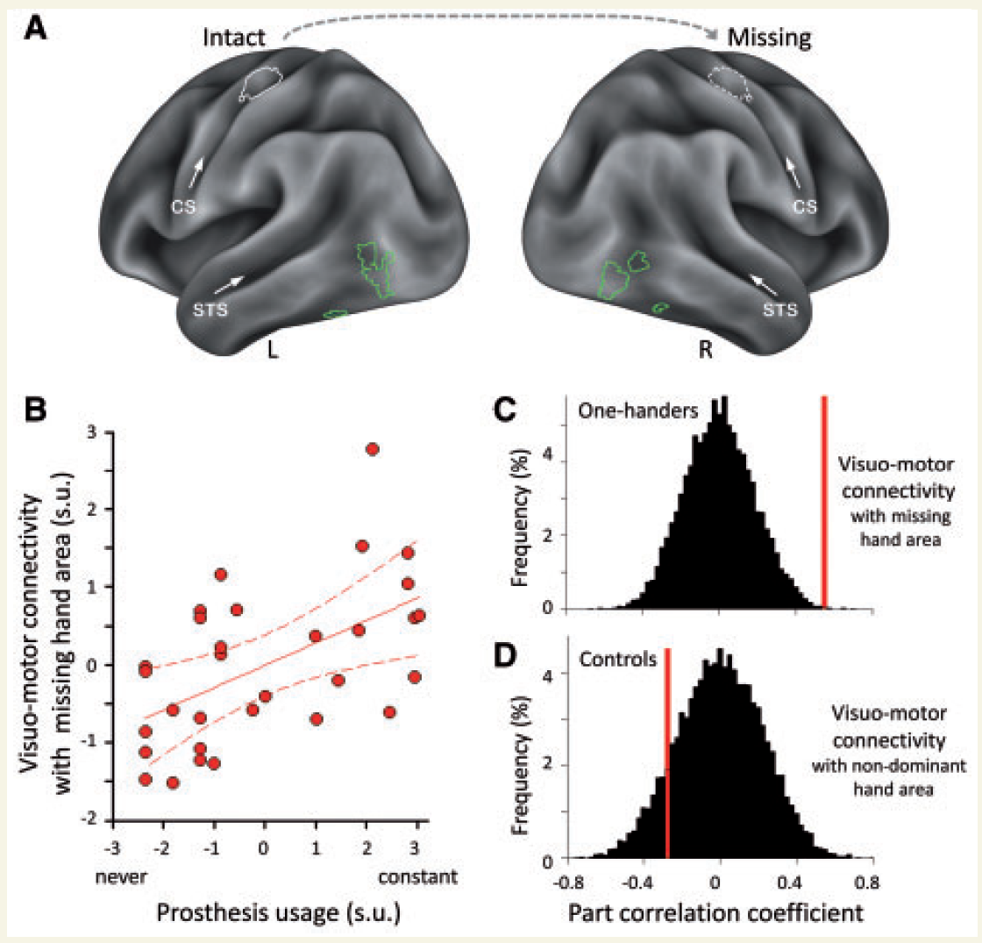
Figure 6. Everyday prosthesis use is associated with altered responses and connectivity across hand-selective visual and sensorimotor regions in individuals with unilateral hand absence. Note. Adapted from “Artificial limb representation in amputees,” by F. M. Z. van den Heiligenberg et al., 2018, Brain, 141(5), 1422–1433 (https://doi.org/10.1093/brain/awy054). Copyright 2018 by the authors.

Can a prosthetic be implanted later in life and work?
Yes, prosthetic implantation/fitting later in life can work and often yields meaningful benefit, but outcomes are strongly context dependent. Functional gains are influenced by device comfort, reliability, training continuity, psychosocial adaptation, and alignment with daily activity demands (Ku et al., 2019; Loeb & Richmond, 2021).
Psychological adjustment literature also indicates that self-efficacy and emotional adaptation are major determinants of sustained use and quality-of-life benefit after limb loss (Ali et al., 2021). This aligns with long-standing rehabilitation observations that prosthetic success is not purely technical; social support, motivation, and realistic goal-setting affect retention as much as hardware sophistication (Datta & Ibbotson, 1995).
For late-life advanced systems specifically, emerging bidirectional and implanted peripheral systems suggest long-term use is increasingly feasible, including home/community-oriented trajectories, but continued monitoring of complications, infection risk, and maintenance demands remains essential (Cady et al., 2025; FDA, 2021).
Thus, “can it work later in life?” is best answered as “yes, frequently—when candidate selection, support systems, and device-service fit are strong.”

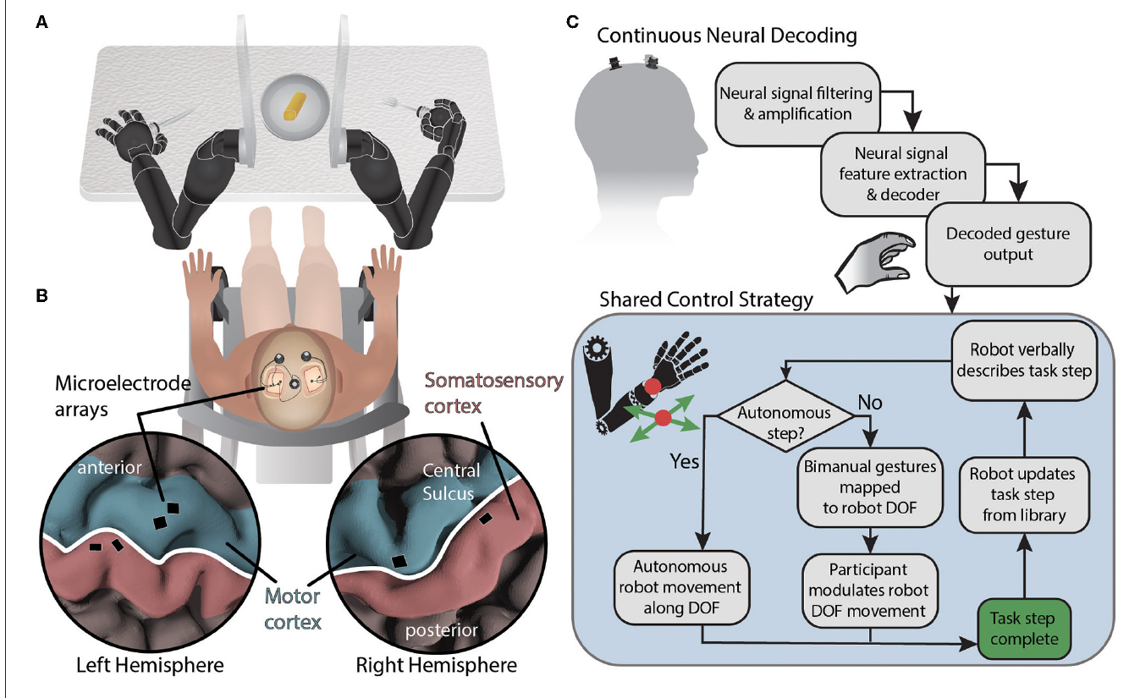
Figure 7. Shared-control architecture enabling bimanual robotic limb coordination for activities of daily living using brain-machine interface gesture decoding and task-dependent degree-of-freedom mapping. Note. Adapted from “Shared control of bimanual robotic limbs with a brain-machine interface for self-feeding,” by D. A. Handelman et al., 2022, Frontiers in Neurorobotics, 16, Article 918001 (https://doi.org/10.3389/fnbot.2022.918001). Copyright 2022 by the authors.

Affordability, access, and evidence quality
Affordability and access are not secondary issues in neuroprosthetics and advanced prosthetic control—they often determine whether a technically promising system ever reaches routine clinical use. Across your sources, cost emerges as a primary barrier to adoption for upper-limb devices, including conventional myoelectric options that can be extremely expensive relative to household budgets, motivating interest in lower-cost fabrication approaches such as 3D printing (Ku et al., 2019). At the same time, translational reviews emphasize that regulatory clearance alone does not guarantee patient access; reimbursement pathways, payer evidence expectations, and the economics of long-term maintenance can dominate real-world deployment decisions (Loeb & Richmond, 2021). This creates a structural mismatch: the most capable interfaces (especially implanted or highly instrumented systems) may be feasible in specialized centers long before they are broadly affordable or sustainably supported in community care settings (Bowsher et al., 2016; U.S. Food and Drug Administration, 2021).
Your affordability-related evidence is strongest in two complementary directions. First, low-cost myoelectric approaches can produce measurable functional gains in patient-reported outcomes over short follow-up windows, demonstrating that “lower price” does not automatically mean “no clinical benefit,” even when control sophistication is limited (Ku et al., 2019). Second, systematic evidence on 3D-printed prostheses suggests potential advantages in customization, accessibility, and user satisfaction, but the clinical literature remains thin and uneven: a recent systematic review screened a very large number of records yet included only a small set of clinical outcome studies, highlighting limited high-quality comparative evidence and heterogeneous outcome measures (Atallah et al., 2025). That pattern matters for engineering conclusions: 3D printing may be an important access lever, but claims about superiority, durability, and long-term cost-effectiveness should be framed cautiously until larger, more standardized trials exist (Atallah et al., 2025).
Training and service access also shape affordability in a broader sense—if patients cannot obtain sufficient therapy, device tuning, or follow-up, the effective “cost” of successful use rises in time, travel, and abandonment risk. Reviews on virtual and computer-aided training argue these modalities can improve training flexibility and reduce some traditional rehabilitation cost burdens, but also note unresolved issues around realism, closed-loop fidelity, and multimodal integration (Liu et al., 2023). Older multidisciplinary prosthetic rehabilitation audits similarly show that acceptance and long-term wearing patterns depend on comfort, perceived function, cosmesis, and psychosocial context—not only hardware capability—so “access” includes whether patients receive appropriate education, peer support, and ongoing prosthetic service (Datta & Ibbotson, 1995).
Taken together, the affordability/access story in your source set is consistent and sobering: advanced neuroprosthetic pathways may expand what is possible, but equitable delivery requires parallel progress in cost, reimbursement, service infrastructure, and evidence quality. Until studies routinely report standardized functional endpoints, adverse events, maintenance needs, and long-term use patterns—rather than one-off demonstrations—policymakers and payers will remain cautious, and many patients will continue to be priced out of the most sophisticated options (Lindner et al., 2010; Atallah et al., 2025).
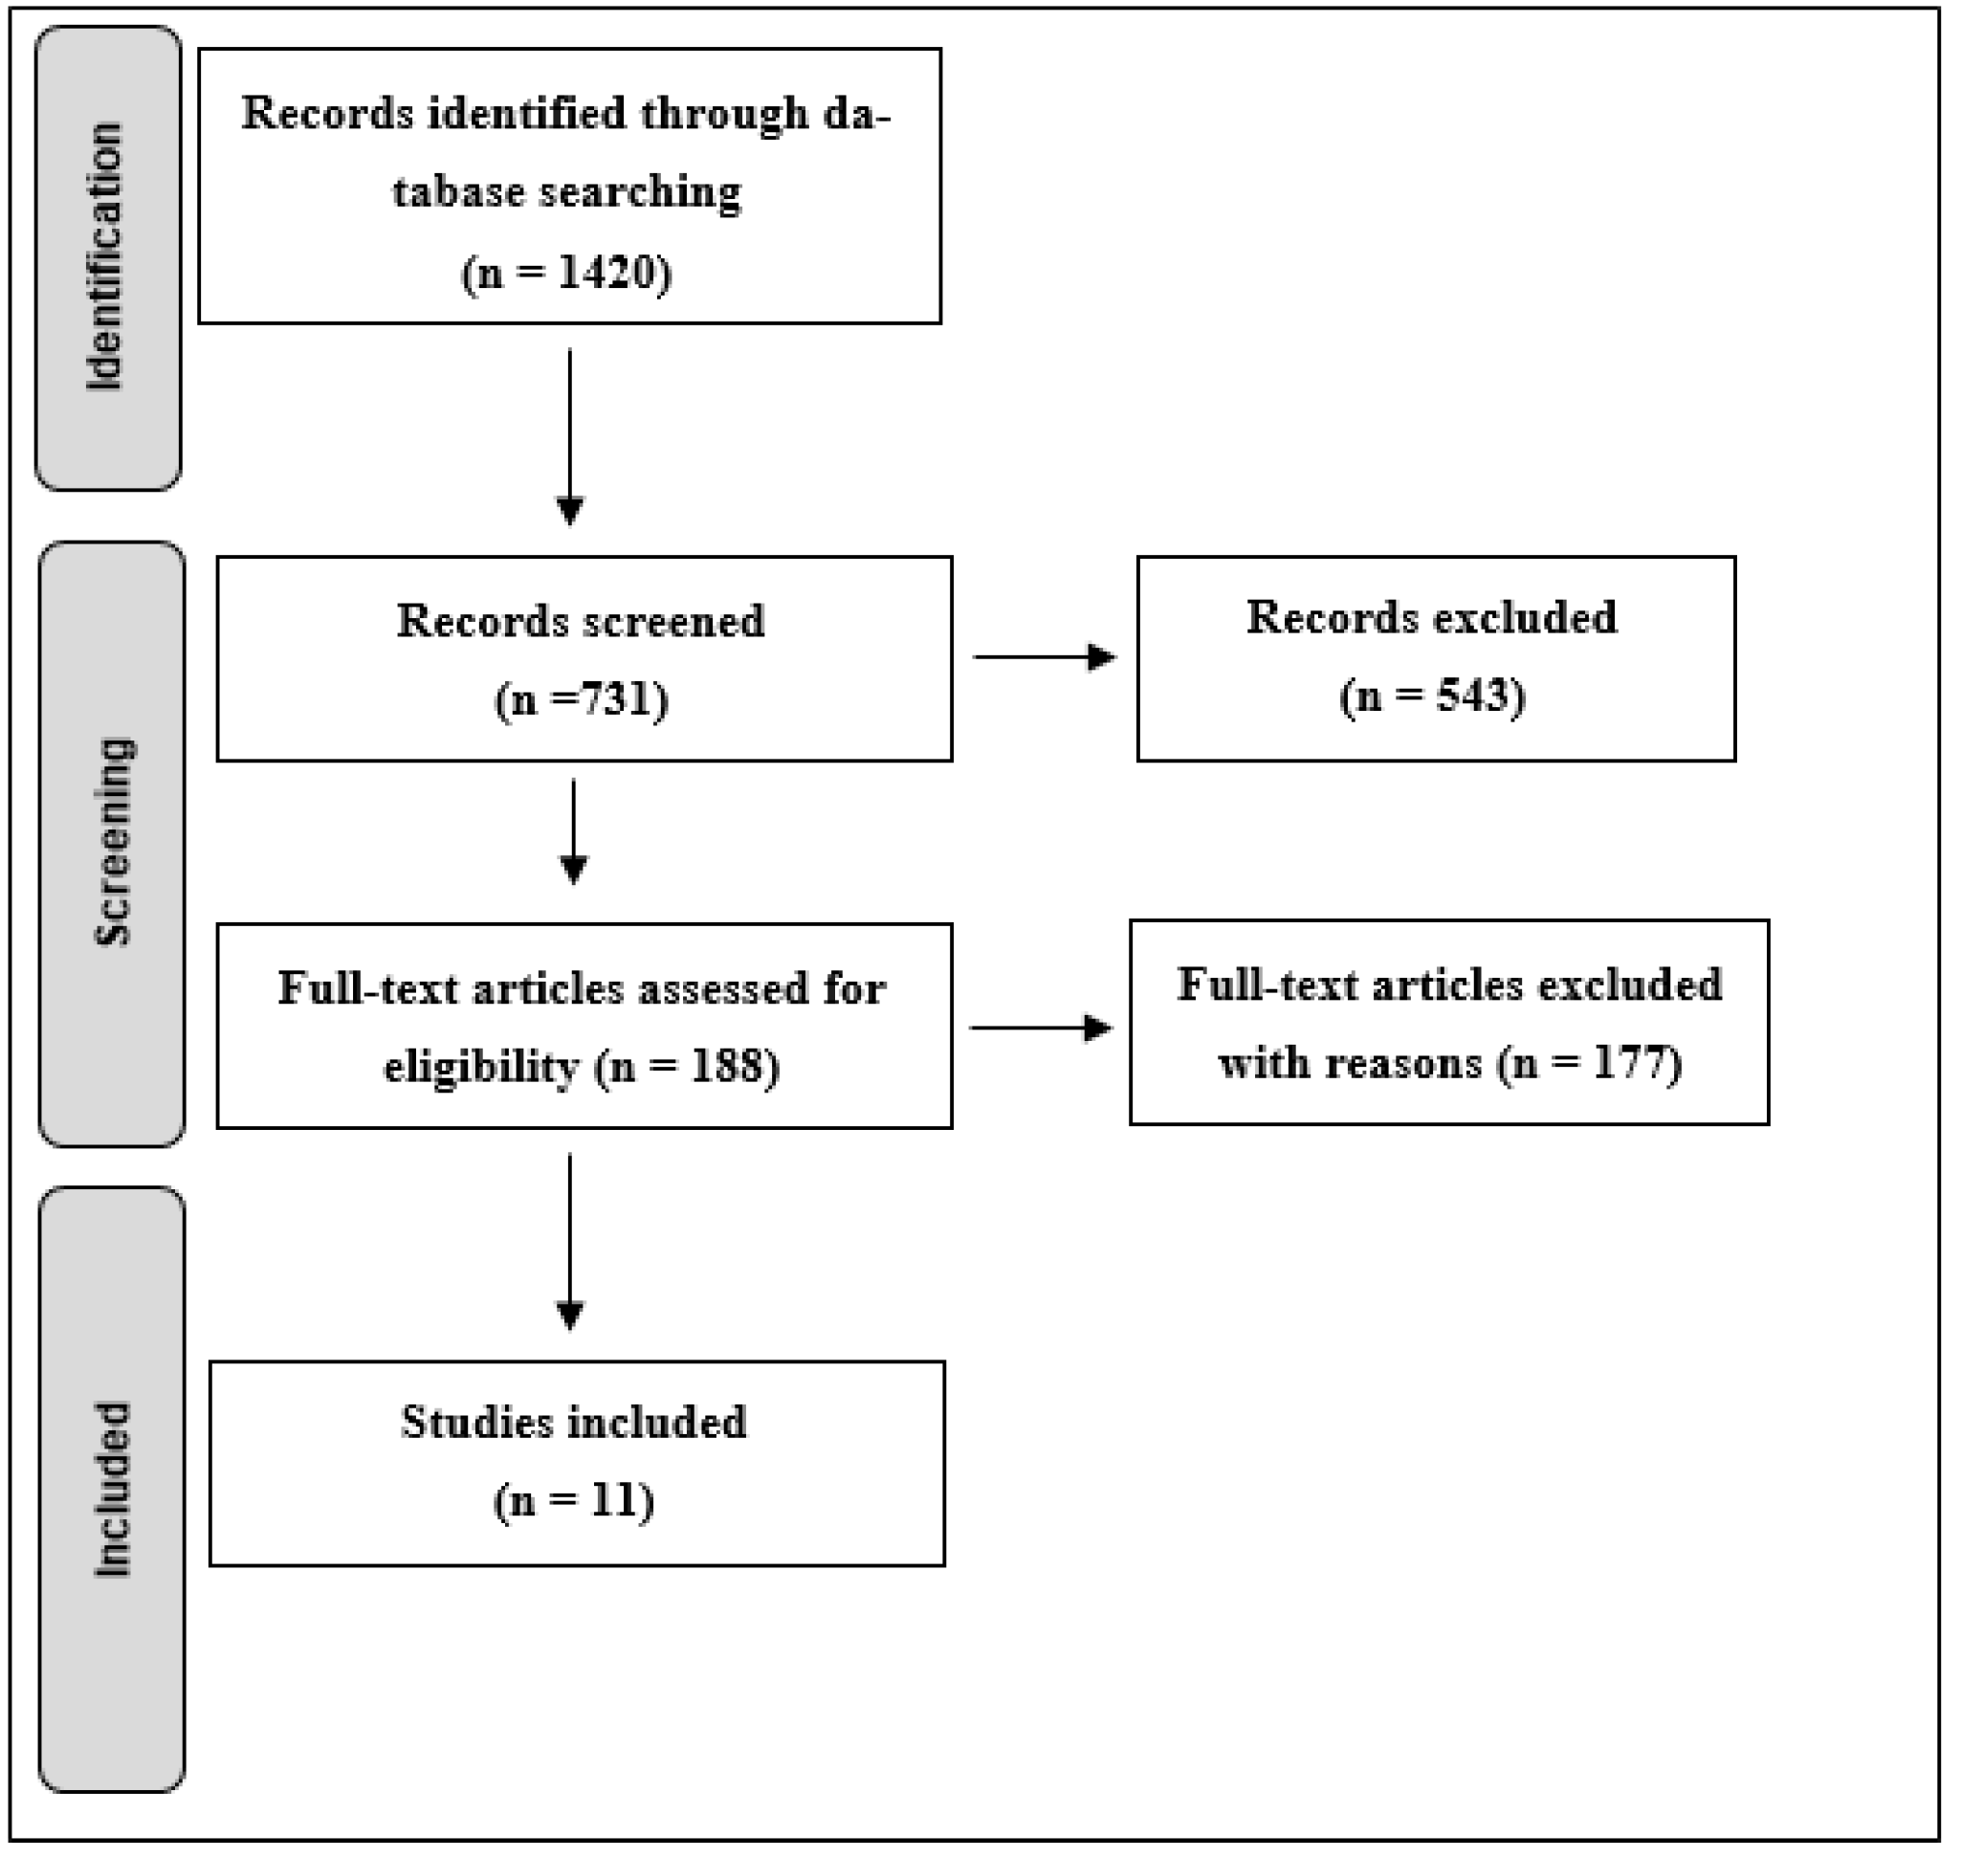
Figure 8. PRISMA study selection flow for clinical outcomes research on 3D-printed prostheses, summarizing evidence breadth and inclusion constraints in the current literature. Note. Adapted from “The current state of 3D-printed prostheses clinical outcomes: A systematic review,” by H. Atallah et al., 2025, Journal of Functional Biomaterials, 16(10), 370 (https://doi.org/10.3390/jfb16100370). Copyright 2025 by the authors.

Conclusion
Across the assembled evidence, BCI prosthetics are technically credible and clinically promising, especially when sensory feedback is integrated into control loops. The field is transitioning from isolated demonstrations to translational system design, where reliability, user burden, and healthcare integration determine impact as much as decoding performance.
The five guiding questions converge on one practical conclusion: the future is not a single technology, but a stratified ecosystem. BCIs are likely indispensable for high-need profiles, while peripheral, myoelectric, low-cost, and hybrid pathways remain essential for broader access. Developmental subgroup differences (congenital vs. acquired), psychosocial adaptation, and rigorous outcome standardization should be treated as core engineering and clinical design variables, not secondary considerations.

References
Ali, S., Waqar, M., Anwar, M., Zahid, M., Satar, A., & Arif, M. (2021). Self-esteem as a predictor of psychological adjustment to limb loss: A case study of acquired limb amputation. Journal of Gandhara Medical and Dental Science, 8(3), 53–59. https://doi.org/10.37762/jgmds.8-3.196
American Academy of Physical Medicine and Rehabilitation. (n.d.). Congenital upper limb anomalies. PM&R KnowledgeNow. https://now.aapmr.org/congenital-upper-limb-anomalies/
Atallah, H., Qufabz, T., Naeem, R., Bakhsh, H. R., Ferriero, G., Varga, D., Derkács, E., & Molics, B. (2025). The current state of 3D-printed prostheses clinical outcomes: A systematic review. Journal of Functional Biomaterials, 16(10), 370. https://doi.org/10.3390/jfb16100370
Bowsher, K., Civillico, E. F., Coburn, J., Collinger, J., Contreras-Vidal, J. L., Denison, T., Donoghue, J., French, J., et al. (2016). Brain–computer interface devices for patients with paralysis and amputation: A meeting report. Journal of Neural Engineering, 13(2), 023001. https://doi.org/10.1088/1741-2560/13/2/023001
Cady, S. R., Lambrecht, J. M., Dsouza, K. T., Dunning, J. L., Anderson, J. R., Malone, K. J., Chepla, K. J., Graczyk, E. L., & Tyler, D. J. (2025). First-in-human implementation of a bidirectional somatosensory neuroprosthetic system with wireless communication. Journal of NeuroEngineering and Rehabilitation, 22, 90. https://doi.org/10.1186/s12984-025-01613-z
Callier, T., Schluter, E. W., Tabot, G. A., Miller, L. E., Tenore, F. V., & Bensmaia, S. J. (2015). Long-term stability of sensitivity to intracortical microstimulation of somatosensory cortex. Journal of Neural Engineering, 12(5), 056010. https://doi.org/10.1088/1741-2560/12/5/056010
Chen, K. H., Dammann, J. F., Boback, J. L., Tenore, F. V., Otto, K. J., Gaunt, R. A., & Bensmaia, S. J. (2014). The effect of chronic intracortical microstimulation on the electrode–tissue interface. Journal of Neural Engineering, 11(2), 026004. https://doi.org/10.1088/1741-2560/11/2/026004
Datta, D., & Ibbotson, V. I. (1995). Prosthetic rehabilitation of upper limb amputees: A five year review. Clinical Rehabilitation, 9(4), 311–317.
U.S. Food and Drug Administration. (2021). Implanted brain-computer interface (BCI) devices for patients with paralysis or amputation—Non-clinical testing and clinical considerations: Guidance for industry and Food and Drug Administration staff. https://www.fda.gov/media/120362/download
Flesher, S. N., Downey, J. E., Weiss, J. M., Hughes, C. L., Herrera, A. J., Tyler-Kabara, E. C., Boninger, M. L., Collinger, J. L., & Gaunt, R. A. (2021). A brain-computer interface that evokes tactile sensations improves robotic arm control. Science, 372(6544), 831–836. https://doi.org/10.1126/science.abd0380
Handelman, D. A., Osborn, L. E., Thomas, T. M., Badger, A. R., Thompson, M., Nickl, R. W., Anaya, M. A., Wormley, J. M., Cantarero, G. L., McMullen, D., Crone, N. E., Wester, B., Celnik, P. A., Fifer, M. S., & Tenore, F. V. (2022). Shared control of bimanual robotic limbs with a brain-machine interface for self-feeding. Frontiers in Neurorobotics, 16, 918001. https://doi.org/10.3389/fnbot.2022.918001
Korkmaz, M., Erbahçeci, F., Ülger, Ö., & Topuz, S. (2012). Evaluation of functionality in acquired and congenital upper extremity child amputees. Acta Orthopaedica et Traumatologica Turcica, 46(4), 262–268. https://doi.org/10.3944/AOTT.2012.2631
Ku, I., Lee, G. K., Park, C. Y., Lee, J., & Jeong, E. (2019). Clinical outcomes of a low-cost single-channel myoelectric-interface three-dimensional hand prosthesis. Archives of Plastic Surgery, 46(4), 303–310. https://doi.org/10.5999/aps.2018.01375
Lee, M. B., Kramer, D. R., Peng, T., Barbaro, M. F., Liu, C. Y., Kellis, S., & Lee, B. (2019). Brain-computer interfaces in quadriplegic patients. Neurosurgery Clinics of North America, 30(2), 275–281. https://doi.org/10.1016/j.nec.2018.12.009
Liu, X., Zhang, D., Miao, K., Guo, Y., Jiang, X., Zhang, X., Jia, F., Tang, H., & Dai, C. (2023). A review on the usability, flexibility, affinity, and affordability of virtual technology for rehabilitation training of upper limb amputees. Bioengineering, 10(11), 1301. https://doi.org/10.3390/bioengineering10111301
Loeb, G. E., & Richmond, F. J. (2021). Turning neural prosthetics into viable products. Frontiers in Robotics and AI, 8, 754114. https://doi.org/10.3389/frobt.2021.754114
Maimon-Mor, R. O., Schone, H. R., Slater, D. H., Faisal, A. A., & Makin, T. R. (2021). Early life experience sets hard limits on motor learning as evidenced from artificial arm use. eLife, 10, e66320. https://doi.org/10.7554/eLife.66320
Schwartz, A. B., Cui, X. T., Weber, D. J., & Moran, D. W. (2006). Brain-controlled interfaces: Movement restoration with neural prosthetics. Neuron, 52(1), 205–220. https://doi.org/10.1016/j.neuron.2006.09.019
van den Heiligenberg, F. M. Z., Orlov, T., Macdonald, S. N., Duff, E. P., Slater, D. H., Beckmann, C. F., Johansen-Berg, H., Culham, J. C., & Makin, T. R. (2018). Artificial limb representation in amputees. Brain, 141(5), 1422–1433. https://doi.org/10.1093/brain/awy054

